3P Technik

TCS5JBL & TCS5JBLA

Low-Voltage Top-Up Switch

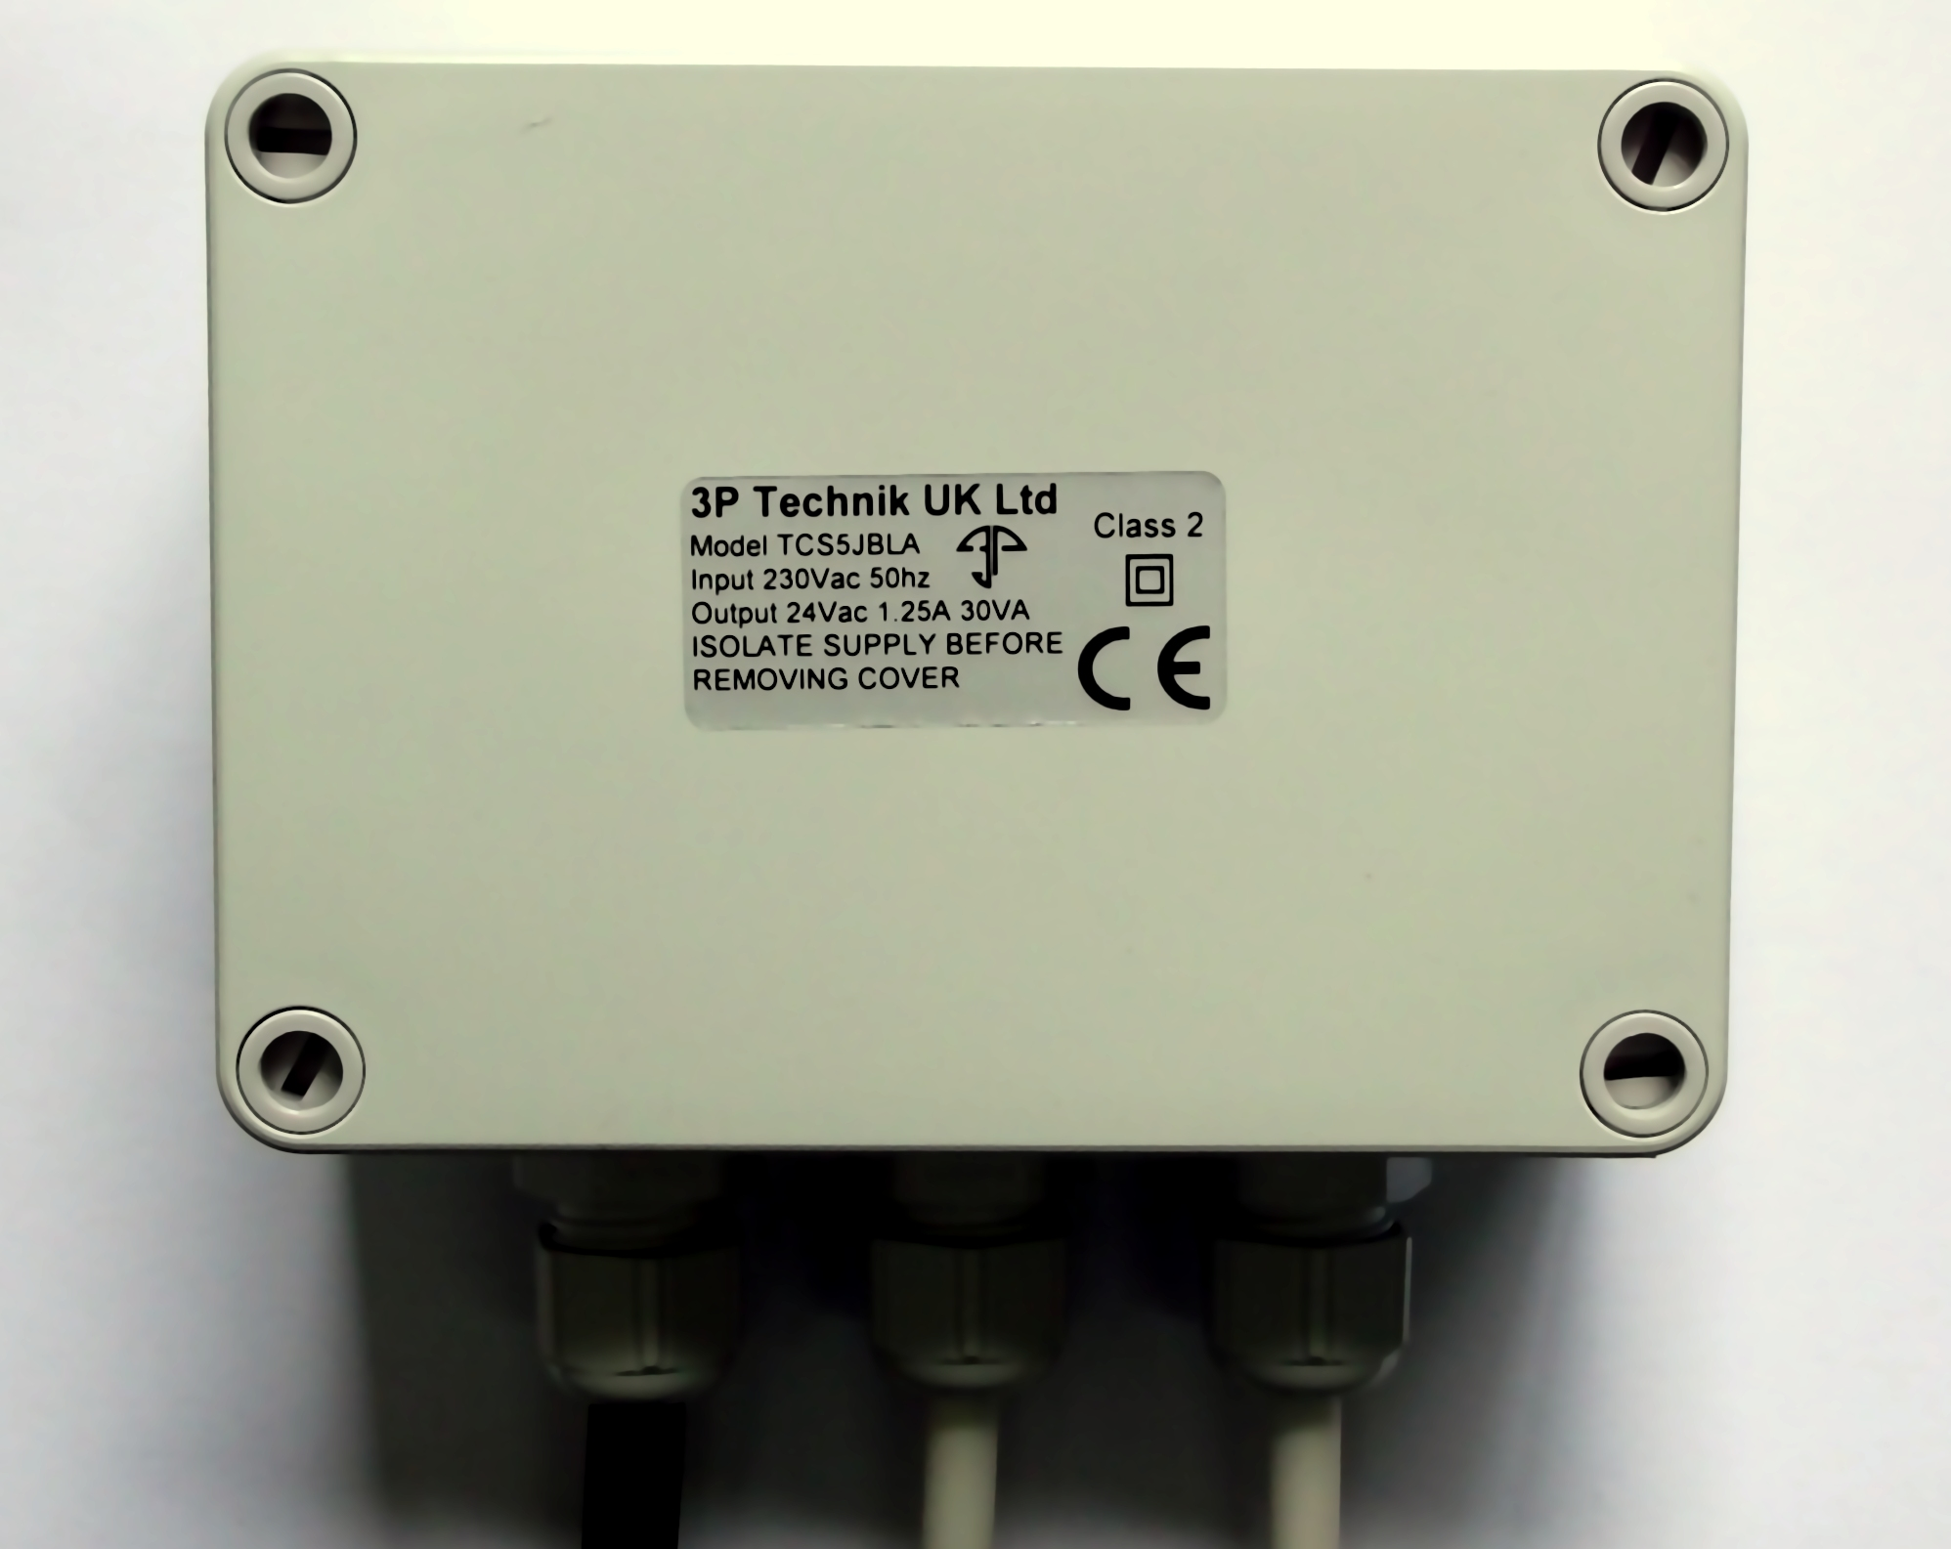
Installation and Operation Manual

Table of Contents
Description Of Operation 2
Installation 2
Safety Precautions 2
Included Components 3
Layout 3
Control Panel Mounting 3
Connections 4
Float Switch 4
Solenoid 4
Mains Supply 230Vac 4
Operation 4
Safety Precautions 4
Adjustments 5
Specifications 5

Description Of Operation

The TCS5JBL Low Voltage Top-up Switch is intended to ensure the availability of water in a tank by topping up the tank when the level becomes low, with a measured amount of mains water.

Water level in the tank is sensed via a float switch, and top-up of mains water is achieved via a solenoid valve connected to the mains water supply.

The solenoid will be activated when the float switch reaches a downward angle of approx 45deg or more, the top-up cycle will then continue until the float switch reaches an upward angle of approx 45deg, thereby ensuring a measured quantity of water is introduced to the tank and avoiding unnecessarily frequent top-ups.

The float switch and solenoid circuits are both powered by a safe low-voltage, either 24Vdc (TCS5JBL) or 24Vac (TCS5JBLA) with limited current and over-voltage protection.

Installation

Safety Precautions
Mains Voltage – There are exposed electrical conductors inside this appliance. This appliance must be installed and serviced by a competent electrical technician to the current requirements of BS7671 and IEEE recommendations. Before servicing this appliance, normal safe isolation procedures should be implemented.
Do not touch any connection terminals while energised.
Do not attempt to service this item when wet, or in a wet or high humidity environment.
If the housing of the control panel becomes damaged, you must shut down and securely isolate this appliance immediately.

Included Components

TCS5JBL/TCS5JBLA Series Control Unit
2 x Male Connecting Plugs

Layout
The control panel can be mounted indoors or in sheltered outdoor locations (barns, covered areas, etc). It is rated at IP66 and will not withstand persistent and direct rain, immersion, etc.
Voltage drop will affect the cable size needed to take power to your appliances. The more current is drawn the greater the effect over distance. Voltage drop will be greater with direct current versions.
The float switch supplied is a 2 way float switch, it is set by default to close the circuit when the float is facing downwards. This suits the majority of tank re-filling applications. If desired it can be re-wired to close when the float is held upwards to suit tank drainage requirements. To do this the wiring within the plug attached to the float switch must be changed. The brown wire is common and connected to the voltage to be switched, blue returns voltage when the float is facing up and black returns voltage when the float faces downwards. Cables extension is straightforward using mains flex, there is no neutral, and there is no earth, only one pole is carried through the float switch. For the extension of float switch cables we recommend an IP68 cable joiner 3P Part number X20BKSD.
Suitable circuit protection must be installed and should include as a minimum a suitable earth, overcurrent protection, and residual current protection at 30mA, ideally on it's own circuit, but always in accordance with BS7671 and applicable regulations.

Control Panel Mounting

Open the cover of the control panel. There are 4 recesses, one on each corner of the panel. Drill through at these locations and attach to the wall or a suitable support, taking care not to damage cabling inside the panel. Fixings are not included and should be selected to suit the material to which the panel will be mounted.

Connections

Float Switch

The 2 outer poles in the plug should be used. Polarity is unimportant for the float switch connection. If you are using a double switching float switch (3 wires), select the 2 wires which connect when the float switch is hanging downwards.

The float switch cable should be fastened within the tank between the points at which you want the top-up cycle to start and stop. The distance between start and stop is determined by the length of free cable to the float.

Solenoid

The polarity of the solenoid connection is unimportant if you have the AC version of this unit (TCS5JBLA). If using the DC version, the pole marked L in the plug will be positive, and the pole marked N will be negative, although it is good practice to verify this with a multimeter during installation.

Mains Supply 230Vac

The mains power supply cable is pre-wired. Connect to a fused outlet or isolator as usual. This is a Class 2 isolated appliance without earth, but the earth wire must still be connected and validated as usual to provide safety in the event of damage to the supply cable.

Current draw is shown at the end of this manual under Specifications.

NOTE – Do not coil the cables, cut them to an appropriate length. Coiled cables suffer increased impedance and are susceptible to voltage induction from nearby circuits and appliances. Where possible try to maintain a separation of at least 150mm between mains power cables and low voltage cables.

Operation

Safety Precautions
Mains Voltage – There are exposed electrical conductors inside this appliance. This appliance must be installed and serviced by a competent electrical technician to the current requirements of BS7671 and IEEE recommendations. Before servicing this appliance, normal safe isolation procedures should be implemented.
Do not touch any connection terminals while energised.
Do not attempt to service this item when wet, or in a wet or high humidity environment.
If the housing of the control panel becomes damaged, you must shut down and securely isolate this appliance immediately.

Adjustments

Operation is automatic. There are no adjustments to be made at the control unit.

Non-weighted float cables

The level around which the system starts and stops the top-up cycle can be adjusted by moving the point at which the float cable is attached within the tank.

The top-up duration can be adjusted by increasing or decreasing by the length of free cable to the float.

Weighted float cables

If your float switch has a weight attached along it's length, the position of that weight can be adjusted. You may need to secure it with a cable tie.

The level around which the system starts and stops the top-up cycle can be raising or lowering the float into the tank.

The top-up duration can be adjusted by increasing or decreasing by the length of free cable between the float and the weight.

Specifications
Dimensions (W x H x D) 130mm x 94mm x 57mm
Enclosure Material Polystyrene
Ingress Protection IP66
UV Resistant
Output TCS5JBL 24Vdc 0.63A max
TCS5JBLA 24Vac 1.25A max

